
FYDP-Form1

FYP Proposal Form

Department of Computer Science Batch __________

FYP Title
Sentinel MCP: A Context-Aware AI Agent for Automated Web Application Security Analysis and Verified Remediation

Domain
IAS – Information Assurance & Security; IS – Intelligent Systems; SE – Software Engineering

Nature of FYP New Project Industrial Collaboration Funded Project
Extension of Existing Project Other Department / Academic Institution

Problem Statement
Web applications may contain security vulnerabilities such as injection flaws, cross-site scripting, exposed secrets, insecure configurations, and missing authorization checks. Developers often discover these problems late in development. Conventional security scanners can produce findings without sufficient application context, making prioritization difficult. AI coding assistants can propose changes, but unverified fixes may fail to eliminate a vulnerability or introduce regressions. Developers need an integrated workflow that detects risks, explains their relevance, proposes controlled changes, and independently verifies the results.

Proposed Solution
We propose Sentinel MCP, a local-first AI-assisted security agent that connects to compatible development clients through the Model Context Protocol (MCP). The system will:
• Integrate selected static-analysis, dependency, and secret-scanning tools to detect supported vulnerability classes.
• Build a lightweight application-context graph and provide evidence-based explanations and risk prioritization.
• Suggest or generate candidate code patches, requiring approval for sensitive or high-impact changes.
• Verify eligible changes in an isolated workspace using tests and rescanning, with rollback or escalation when checks fail.

Scope of the Project

The project will focus on selected JavaScript/TypeScript and Python web-application frameworks, with exact framework coverage finalized during requirements analysis. Supported vulnerability categories will include a manageable subset of injection patterns, XSS, exposed secrets, insecure configurations, vulnerable dependencies, and authorization weaknesses. The project includes an MCP server, scanning workflow, normalized findings, context graph, AI-assisted explanation and ranking, policy-controlled remediation, independent verification, audit history, and a basic developer interface. Automatic fixes will be limited to explicitly permitted, reversible cases. The project excludes unauthorized security testing, production auto-remediation, guaranteed detection of all vulnerabilities, and automatic credential rotation.

Development / Research Methodology

The project will follow an iterative Agile methodology:
1. Requirement Gathering & Analysis: define frameworks, vulnerability classes, threat model, user requirements, and acceptance criteria.
2. System Design: design the MCP tools, scanning pipeline, findings schema, context graph, risk model, patch policy, and interface.
3. Security Analysis Integration: connect selected scanners and normalize their results.
4. AI / Context Development: implement contextual reasoning, evidence-grounded explanations, and transparent risk ranking; evaluate whether a small ML model is justified by available labels.
5. Implementation in Sprints: build MCP integration, candidate patch generation, approval workflow, isolated testing, rescanning, and rollback.
6. Testing and Evaluation: compare scanner-only and context-aware findings and assess verified remediation success, regressions, and runtime.
7. Deployment, Feedback & Documentation: deliver a reproducible local demonstration, technical documentation, and final report.

Resources Involved
Development will mainly open-source resources. Python and the official MCP SDK will support the MCP server and orchestration. Candidate scanners include Semgrep, Bandit, ESLint security rules, CodeQL where suitable, OSV-Scanner, and secret-scanning utilities. NetworkX may support the context graph, while SQLite or JSON will store findings and audit records. A configurable LLM adapter will support explanations and patch proposals; external code transmission will be disabled by default unless explicitly authorized. React/TypeScript may be used for a dashboard, and pytest/Jest/Vitest for tests. Git/GitHub, Figma, and team collaboration tools will support development. Authorized benchmark applications such as OWASP Juice Shop, OWASP Benchmark, and selected SARD/Juliet cases will be evaluated for suitability. Final choices depend on tool support, licensing, and project time.

Final Outcome / Deliverables
The final outcome will be a functional Sentinel MCP demonstrating a developer-oriented workflow to detect, explain, prioritize, and verify remediation of selected web-application security issues. Deliverables will include an MCP server, integrated scanning and normalized findings, an application-context graph, AI-assisted explanations and prioritization, policy-controlled patch suggestions, isolated verification with rescanning and rollback for supported cases, an audit/reporting interface, evaluation results, source code, installation guide, test cases, and the final project report. Security outcomes and limitations will be documented without claiming complete protection.

Learning Outcome
The team will gain hands-on experience in secure software engineering, application-security analysis, MCP-based tool integration, AI-assisted reasoning, contextual risk assessment, code patching, sandboxed testing, and reproducible evaluation. Additional learning outcomes include software architecture, Python and TypeScript development, threat modelling, collaboration, version control, UI design, technical documentation, and responsible use of AI for security tasks.

Industrial Support (if any) __________________________-________________________________
FYP Team members:
S. No. | Name of the Student | IU Regn No | CGPA | Signature
1 | Ammar Ahmed Abbasi | 63199 | 2.4
2 | Muhammad Alam | 64759 | 2.6
3 | Marif Ahmed | 61208 | 2.1
4 | Shaheer ul Ibrahim | 58512 | 2.3

Details of Supervisor / Industrial Advisor:

 | Name | Designation &  Department | Contact No. | Signature
Supervisor | Dr. Lubna Aziz
Co-Supervisor
(if any)
Industrial Advisor
(if any)

Project Schedule
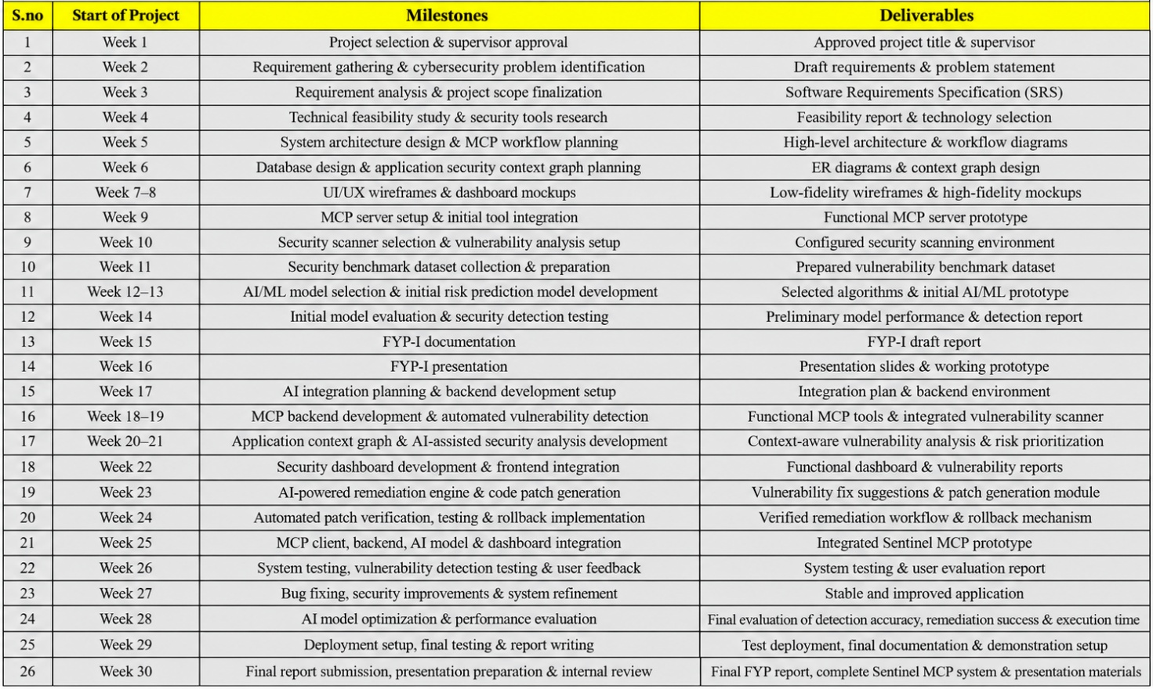

Gantt Chart
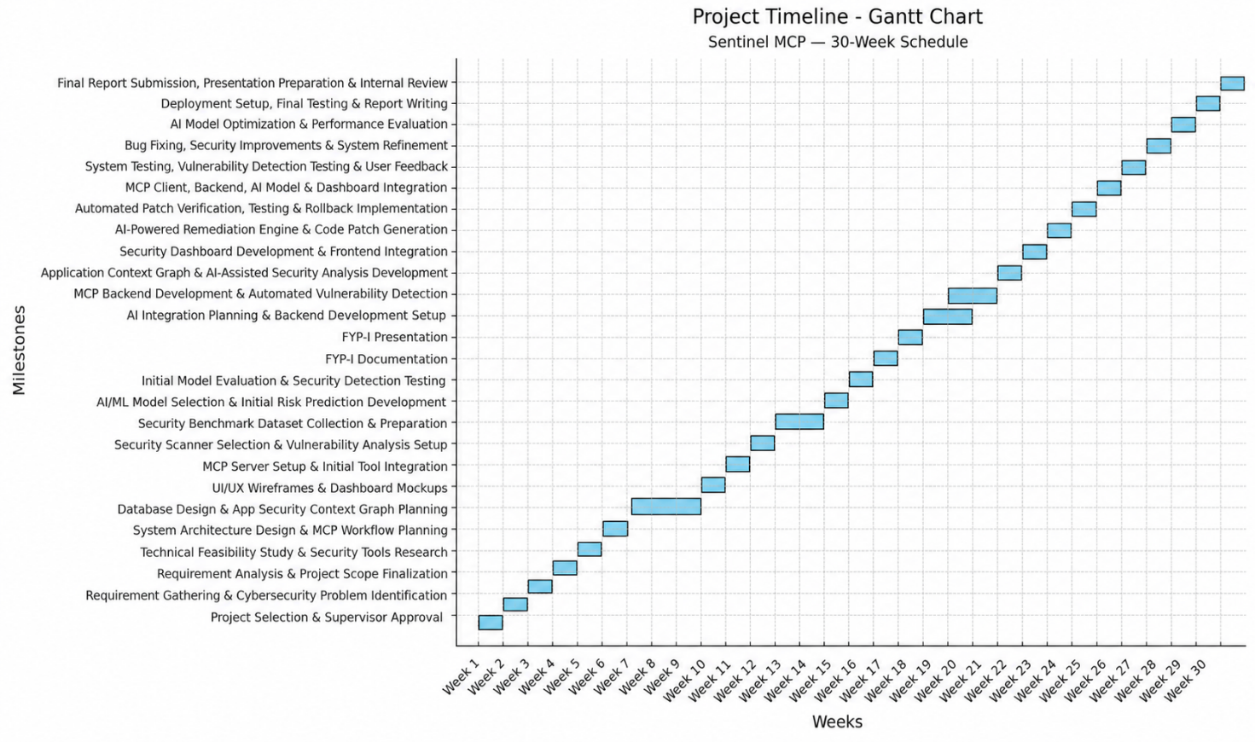

FYP to Sustainable Development Goals (SGDs) Mapping:
SGDs | Mapping | Description
SDG 01. No poverty
SDG 02. Zero hunger
SDG 03. Good health and well-being
SDG 04. Quality
education
SDG 05. Gender equality
SDG 06. Clean water and sanitation
SDG 07. Affordable and clean energy
SDG 08. Decent work and economic growth | ✓ | Supports secure software development skills relevant to digital work.
SDG 09. Industry, innovation, and infrastructure | ✓ | Promotes innovation in AI-assisted application-security engineering.
SDG 10. Reduced inequalities
SDG 11. Sustainable
cities and communities
SDG 12. Responsible consumption and production
SDG 13. Climate action
SDG 14. Life below water
SDG 15. Life on land
SDG 16. Peace, justice and strong institutions | ✓ | Contributes to more trustworthy digital systems through vulnerability analysis and verified remediation.
SDG 17. Partnerships for the goals

FYP to Complex Computing Problem (CCP) Mapping:
CCP Attribute | WP1 and some or all of WP2 to WP7: | FYPD to CCP Mapping  How it is addressed in FYPD
Depth of knowledge required | WP1: one or more of ACM Knowledge Ara | Combines cybersecurity, intelligent systems, and software engineering.
Range of conflicting requirements | WP2: wide-ranging or Conflicting technical, engineering/computing and other issues | Balances security, usability, privacy, runtime, and safe automation.
Depth of analysis required | WP3: no obvious solution | Determines exploit-relevant context and whether patches remove flaws without regressions.
Familiarity of issues | WP4: Involve infrequently encountered issues | Handles diverse code structures, security findings, and AI-generated changes.
Extent of applicable codes | WP5: outside problems encompassed by standards and codes of practice | Applies established security practices to a custom context and verification workflow.
Extent of stake-holder involvement and conflicting requirements | WP6: diverse groups of stakeholders with widely varying needs | Addresses developer productivity, project-owner risk, and end-user security.
Interdependence | WP7: many component parts or sub-problems | Coordinates MCP, scanners, context graph, AI, patch policy, testing, and audit records.
For office use only:
- Proposal  Approved | - Not Approved | - Returned for Clarification / Modification
Comments
(if any):
Project Serial No. |  | Date:
Signature  FYP Coordinator |  | Signature  Chairperson
Signature Associate Dean / Dean

Annexure – A

Knowledge Areas in ACM

# | ACM Knowledge Area | Your Project Mapping to ACM Knowledge Area
1 | AL-Algorithms and Complexity | —
2 | AR-Architecture and Organization | Risk ranking and analysis workflow
3 | CN-Computational Science | MCP service and orchestration architecture
4 | DS-Discrete Structures | —
5 | GV-Graphics and Visualization | Application-context graph representation
6 | HCI-Human-Computer Interaction | Developer dashboard and findings interface
7 | IAS-Information Assurance & Security | Vulnerability analysis, secure patch policy, and verification
8 | IM-Information Management | Findings storage and audit history
9 | IS-Intelligent Systems | AI-assisted explanation and contextual risk prioritization
10 | NC-Networking and Communication | MCP communication with development clients
11 | OS-Operating Systems | Isolated test execution and local environment controls
12 | PBD-Platform-based Development | Integration with supported development platforms
13 | PD-Parallel and Distributed Computing | —
14 | PL-Programming Languages | JavaScript/TypeScript and Python code analysis
15 | SDF-Software Development Fundamentals | Testing, version control, and secure coding practices
16 | SE-Software Engineering | Full software-development lifecycle
17 | SF-Systems Fundamentals | System trust boundaries and execution isolation
18 | SP-Social Issues and Professional Practice | Privacy, responsible AI use, and human approval

